FILE 02 — EXISTING SYSTEM, TECHNOLOGY & COMPETITION RESEARCH

02_EXISTING_SYSTEM_TECHNOLOGY_AND_COMPETITION

PARIKSHAK — Existing System, Technology & Competition Research
Core Question: What already exists, what does it do, what are its limitations, and what technological gap does PARIKSHAK target?

1. Existing Training Approaches
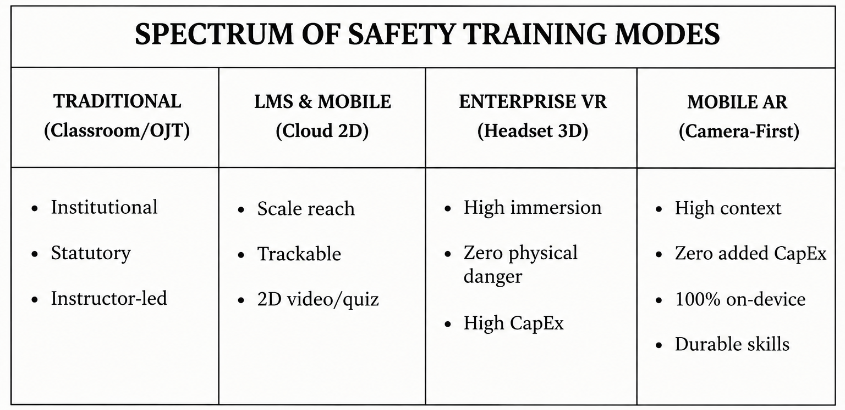
Vocational safety training in the mining and heavy industrial sectors currently relies on four primary approaches. Each targets different aspects of learning, and each has structural trade-offs.

A. Traditional / GVTC Training
Traditional vocational training represents the established statutory model governed by the Directorate General of Mines Safety (DGMS) under the Mines Vocational Training Rules, 1966. [S03] Training is executed primarily through public-sector Group Vocational Training Centres (GVTCs) such as BCCL GVTC Chandmari and CCL Rajrappa. [S03]
Core Modalities
- Classroom Instruction: Frontline lectures, slide decks, and physical text manuals. [S03]
- Demonstrations: Occasional instructor-led tool and safety equipment walkthroughs. [S03]
- On-the-Job Training (OJT): Workplace shadowing under senior supervisor observation. [S03]
- Training Records: Physical paper rosters, attendance sign-in logs, and paper-based certificates. [S03]
Strengths
- Statutory Authority: Direct compliance alignment with DGMS regulations and mandatory mine entry requirements. [S03]
- Institutional Footprint: Established physical centers, permanent instructional staff, and formal company integration. [S03]
- Direct Human Supervision: Trainees interact with experienced instructors who understand local geological hazards. [S03]
Limitations & Structural Constraints
- Passive "Chalk-and-Talk" Delivery: Relies on lecture formats that fail to build practical, consequence-based safety understanding or muscle memory. [S03] [S04]
- Severe Reach Bottleneck: Covers only ~25% of workers prior to job deployment, while 31% report being completely locked out of ongoing skill upgrades. [S03]
- Informal Exclusion: Entirely excludes the estimated 700,000 informal and contract miners operating across Jharkhand. [S01]
- Paper Credential Vulnerability: Paper certificates are easily lost, physically damaged in humid underground environments, or forged, preventing reliable Recognition of Prior Learning (RPL). [S03]
- No Consequence-Based Rehearsal: Classroom settings cannot safely simulate catastrophic events like toxic gas leaks, roof falls, or smoldering coal seam fires. [S04] [S05]

B. LMS & Cloud-Based Mobile Training
Learning Management Systems (LMS) and enterprise mobile safety apps deliver digitized compliance modules, video lectures, and multiple-choice quizzes to worker devices or computer terminals.
Core Modalities
- Microlearning Modules: Short 2D video clips explaining standard operating procedures (SOPs). [S05]
- Digital Assessments: Standard multiple-choice questions (MCQs) evaluating theoretical recall. [S05]
- Centralized Dashboards: Automated cloud records tracking course completion and passing rates. [S05]
Strengths
- Low Distribution Cost: Scalable distribution of standardized training material to large employee bases. [S05]
- Automated Tracking: Centralized compliance dashboards reduce administrative paperwork for HR and safety managers. [S05]
- Self-Paced Learning: Workers can complete training modules asynchronously at their own speed. [S05]
Limitations & Structural Constraints
- Underground Network Blackout: Most commercial LMS platforms require continuous internet connectivity for video streaming and cloud authentication, rendering them non-functional in deep underground shafts. [S06]
- Lack of Spatial & Contextual Learning: 2D video screens cannot project hazards into physical space or teach workers spatial awareness, equipment positioning, or physical blind-zone recognition. [S04]
- Recall vs. Competence: Evaluates what a worker can remember on a written quiz rather than how a worker makes decisions in an emergency. [S04]
- Linguistic Exclusion: Commercial platforms predominantly support English or formal Hindi, excluding regional tribal languages like Santali. [S03]

C. Enterprise Virtual Reality (VR)
Enterprise VR training places workers inside fully synthetic, computer-generated 3D environments via dedicated head-mounted displays (HMDs). Examples include solutions from CHRP-INDIA, AutoVRse, and the Coal India-funded Virtual Reality Mine Simulator (VRMS) developed at IIT (ISM) Dhanbad (supported by public investments such as MCL's ₹6.5 crore VR initiative). [S03] [S05]
Core Modalities
- Fully Immersive HMDs: HTC Vive, Meta Quest, or custom simulator rigs. [S05]
- Synthetic Physics Engines: Controlled simulations of underground roof falls, conveyor entrapment, and blast-zone clearances. [S05]
- Biometric & Behavioral Tracking: Precision recording of head movements, reaction times, and simulated procedural sequencing. [S05]

Strengths
- High Immersion: Provides 360-degree sensory immersion, placing workers directly into life-threatening scenarios with zero physical danger. [S04] [S05]
- Controlled Replicability: Trainees can practice responding to major mine emergencies repeatedly until protocols are memorized. [S05]
- High User Engagement: Interactive 3D mechanics generate higher trainee engagement compared to conventional slide decks. [S05]
Limitations & Structural Constraints
- High Capital Expenditure (CapEx): Enterprise VR headsets cost between $500 and $3,500+ per unit, in addition to computing rigs and maintenance overhead. [S04]
- Environmental Fragility: Delicate optical lenses, tracking sensors, and display screens degrade rapidly when exposed to the high dust, humidity, and heat of real mine sites. [S04]
- Tethered Infrastructure: VR systems are confined to air-conditioned training rooms or dedicated simulator labs, making them difficult to scale across decentralized, remote, or informal work sites. [S04]
- Physiological Discomfort: Extended VR sessions can induce simulator sickness, disorientation, and eye strain, limiting continuous training durations. [S04]
Important Positioning Note: Enterprise VR is not an ineffective technology — it excels at high-immersion laboratory simulation. PARIKSHAK targets a different operational requirement: frictionless, low-cost, decentralized deployability directly onto mid-range smartphones already in workers' hands.

D. Mobile Augmented Reality (AR)
Mobile Augmented Reality (AR) superimposes interactive, spatially registered 3D digital objects onto the real physical environment using standard smartphone cameras, onboard sensors (gyroscopes, accelerometers), and computer-vision tracking frameworks (e.g., Unity AR Foundation, Google ARCore). [S04] [S07]
This is the technological foundation of PARIKSHAK.
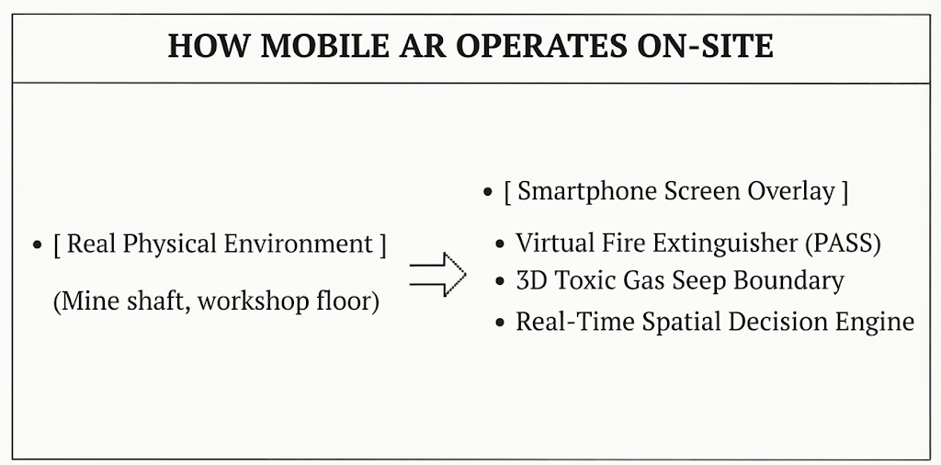
Core Technological Capabilities
- Spatial Overlays: Projects 3D safety assets (extinguishers, gas plumes, evacuation arrows, machinery danger perimeters) directly over the worker's physical surroundings. [S04]
- Interactive Procedural Guidance: Guides trainees step-by-step through safety procedures (such as the PASS fire extinguisher technique or lockout/tagout steps) with real-time feedback. [S04]
- Zero Added Hardware CapEx: Runs entirely on standard mid-range Android 10+ smartphones without external headsets or sensors. [S07]
- Cognitive Augmentation: Acts as an on-demand mental aid, reducing attentional switching, external memory load, and reliance on abstract procedural recall. [S04]
Evidence from Systematic Literature Reviews
A systematic PRISMA review by Tretten et al. (2026) synthesizing 54 quantitative studies from an initial screening of 5,124 records established key performance characteristics for industrial AR: [S04]
- Substantial Reduction in Procedural Errors: AR-guided task execution consistently results in significantly fewer procedural errors during maintenance and assembly compared to static paper instructions. [S04]
- Cognitive Workload Optimization (NASA-TLX): Evaluations using the NASA Task Load Index confirm that well-designed mobile AR systems impose a cognitive workload that is equal to or lower than static paper manuals, particularly during complex, unfamiliar, or safety-critical operations. [S04]
- Acceptable Ergonomic Usability (SUS): Handheld mobile AR consistently scores in the "acceptable" range on the standardized System Usability Scale (SUS). [S04]
- Durable Competence Transfer (Not Tool Dependence): Empirical research confirms that learning gains acquired during AR training persist after visual AR aids are removed, proving that the technology builds durable, long-term competence rather than procedural dependence. [S04]
Design Risks & Human Factors Considerations
For research credibility, mobile AR must be deployed with clear awareness of its human factors limitations:
- Attentional Tunneling: Trainees may focus excessively on visual overlays and miss physical real-world hazards if interfaces are cluttered. [S04]
- Degraded Situational Awareness: Overly dense 3D visual cues can obstruct the user's field of view. Visual overlays must be lightweight, context-triggered, and ergonomically balanced. [S04]
- Device Tracking Variance: Camera tracking fidelity varies across smartphone camera sensors, lighting conditions, and surface textures in dusty underground environments. [S07]

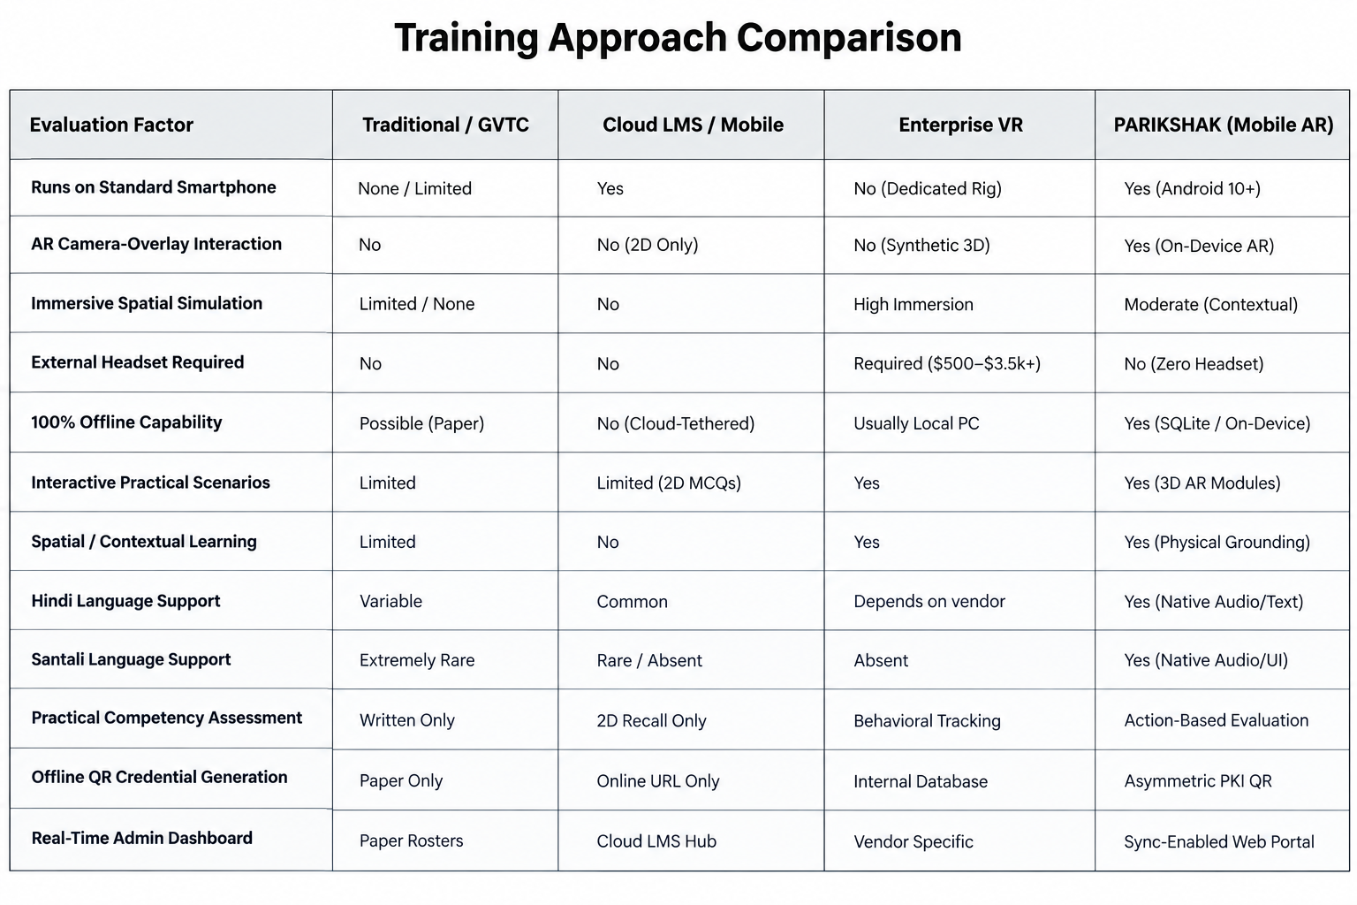
2. AR vs VR vs LMS vs Traditional — Comparative Matrix

3. Competitive Landscape
The competitive landscape is structured by solution category rather than individual brand comparisons, demonstrating where PARIKSHAK fits within the broader ecosystem.
Category 1 — Traditional Vocational Training Infrastructure
- Representative Entities: DGMS-regulated public sector Group Vocational Training Centres (BCCL GVTC Chandmari, CCL Rajrappa, Kathara, Kuju). [S03]
- Core Value Proposition: Statutory compliance monopoly under the Mines Vocational Training Rules, 1966. [S03]
- Structural Vulnerability: Reaches only ~25% of miners pre-job, relies on passive lectures, uses paper certifications prone to damage or fraud, and excludes 700,000 informal workers. [S01] [S03]
Category 2 — Cloud-Based Mobile Safety LMS
- Representative Entities: SafetyCulture (iAuditor), SC Training (formerly EdApp), Safety Gurukul, Safety360.
- Core Value Proposition: Scalable microlearning, rapid deployment, bilingual video content, and automated compliance auditing.
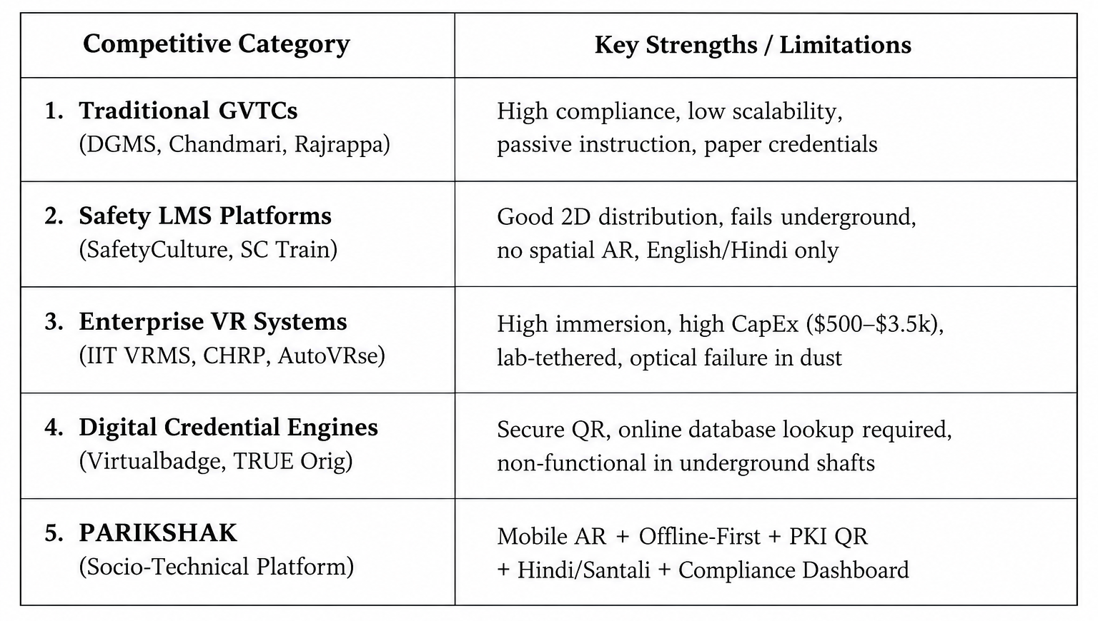
- Structural Vulnerability: Requires live internet connectivity (fails in remote shafts), lacks 3D camera-overlay AR interaction, evaluates only theoretical recall, and lacks tribal language localization (Santali). [S03] [S06]

Category 3 — Enterprise VR Simulators
- Representative Entities: IIT (ISM) Dhanbad VRMS, CHRP-INDIA (17,000+ miners trained), AutoVRse (75,000+ industrial users). [S03] [S05]
- Core Value Proposition: High-immersion 360-degree sensory environments, accurate emergency physics, and risk-free scenario simulation. [S05]
- Structural Vulnerability: Expensive hardware ($500–$3,500+ per HMD), fragile in dusty/humid mine conditions, tied to indoor labs, and impractical for decentralized or informal workforces. [S04]

Category 4 — Digital Credential & Mobile Wallet Platforms
- Representative Entities: Virtualbadge.io, TRUE Original, standard blockchain/cloud badging systems.
- Core Value Proposition: Tamper-proof digital certificates, sharable verifiable credentials, and automated badge distribution.
- Structural Vulnerability: Verification mechanisms require the scanning device to open an online URL or query a central cloud database — failing completely in underground mine shafts. [S07] [S08]
Category 5 — PARIKSHAK (The Proposed Socio-Technical Platform)
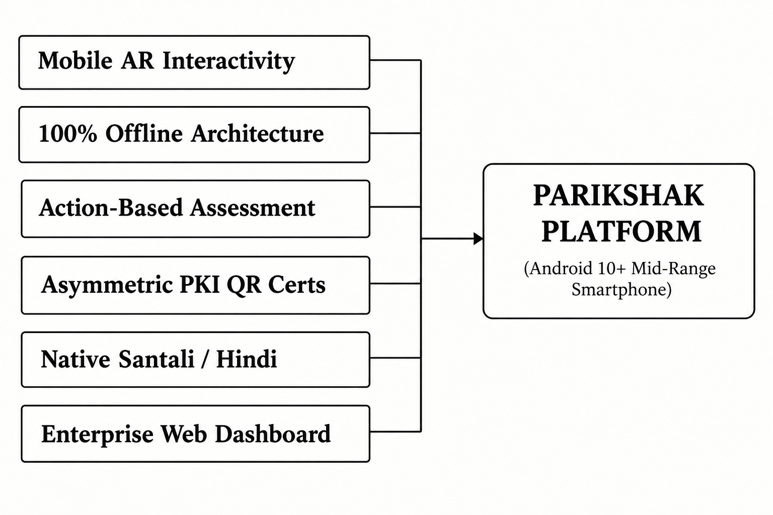
- Unique Positioning: PARIKSHAK integrates capabilities that are currently fragmented across multiple distinct industries into a unified, smartphone-first workflow :

4. Key Competitive Summary Statement
PARIKSHAK does not compete with any single product. Instead, it combines capabilities normally distributed across classroom training (statutory compliance), LMS platforms (scalable administration), enterprise VR (spatial 3D simulation), and digital credential engines (tamper-proof verification) into a single, offline-first, smartphone-based AR platform designed for high-risk industrial workforces.

